***Computer project***

***NAME***

HATEM MOHSEN HAFEZ AHMED

***GROUP***

3

***SEC***

13

***BN***

1

***APPLICATION***

Visual studio

***Screen shots of project***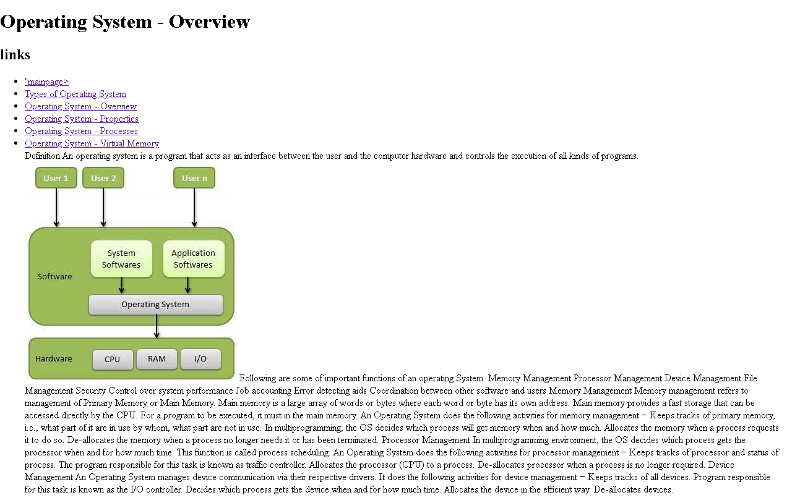

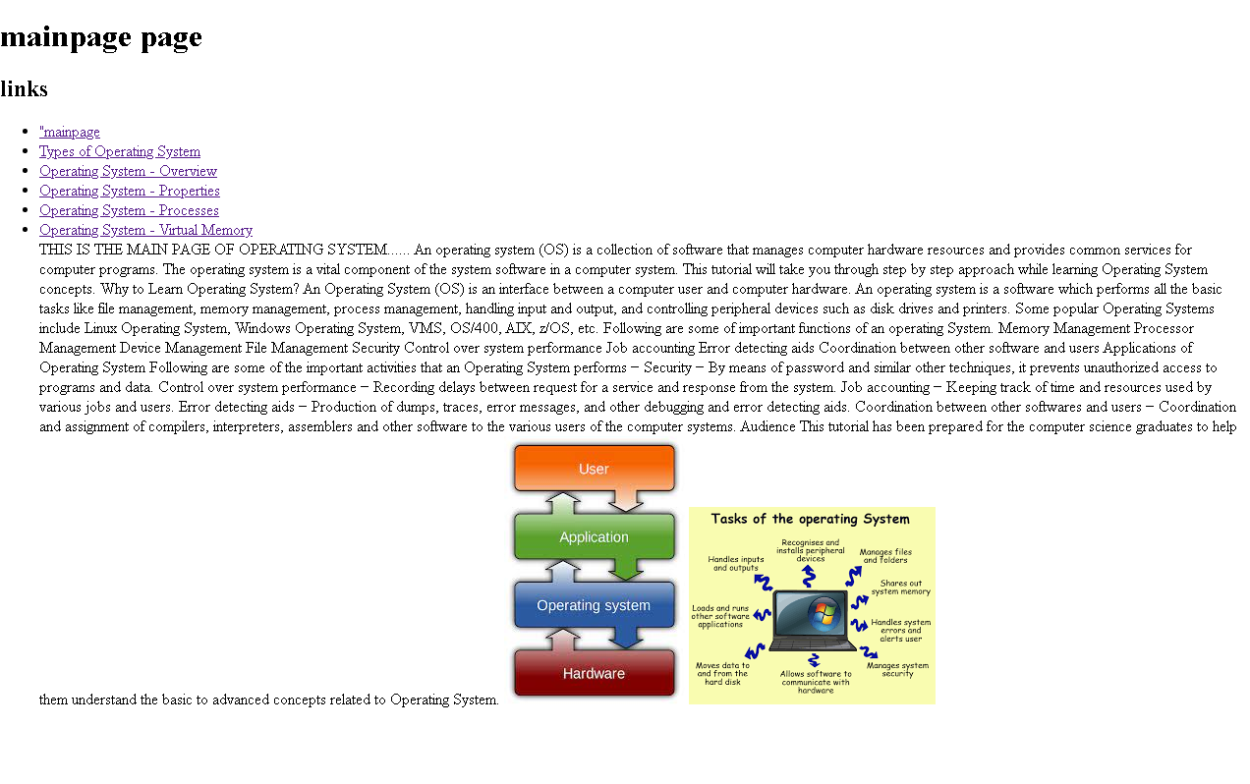

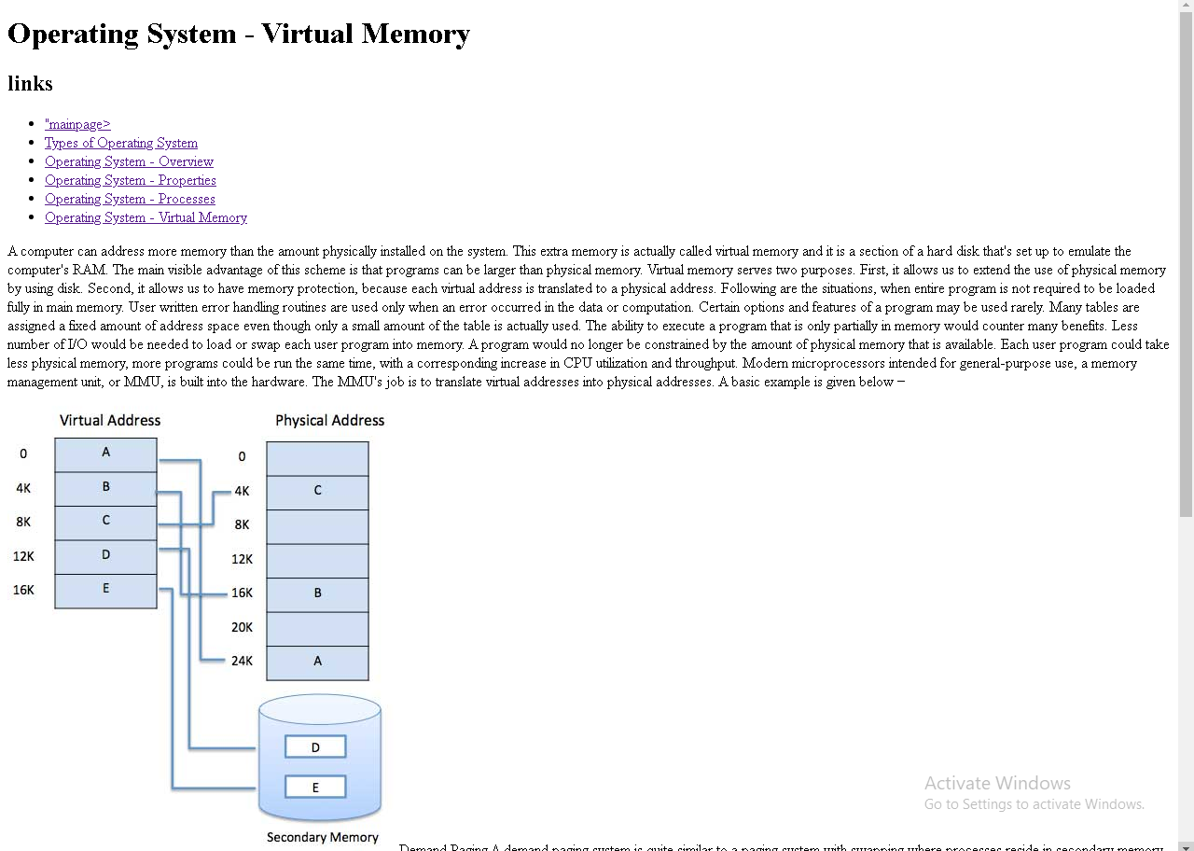

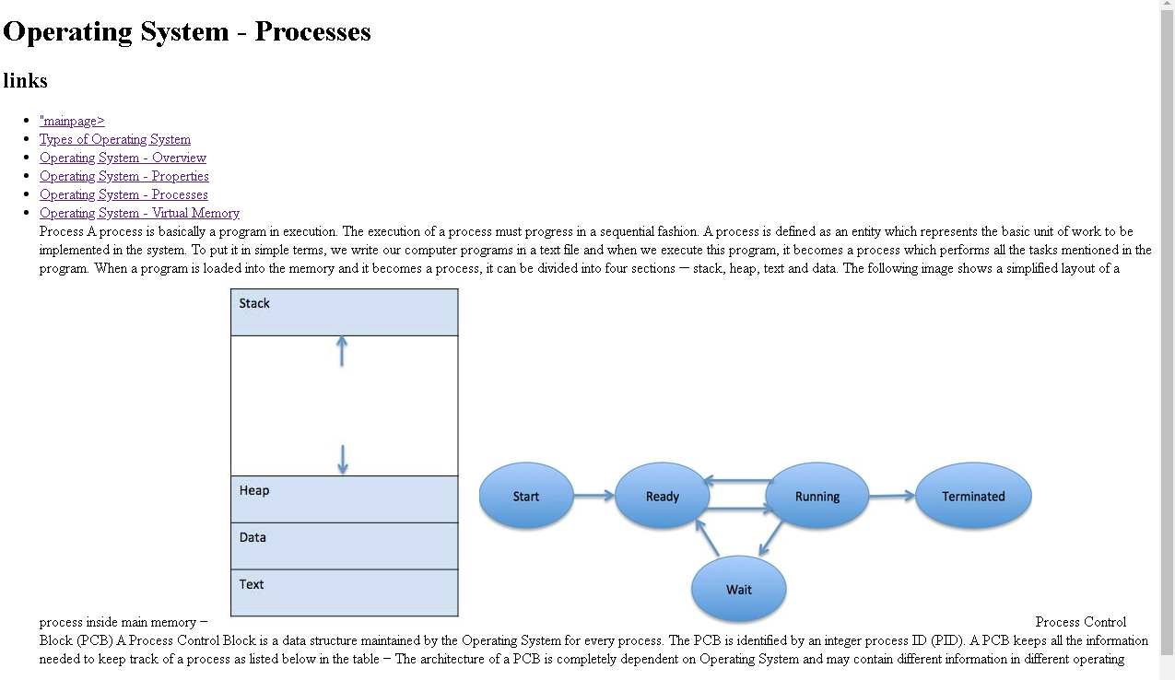

***Source code*** 